Conclusion 14 B

Prim-Jarnik, Kruskal, Baruvka

Prim-Jarnik (The edges in the MST are stored at the vertices by setParent(e))

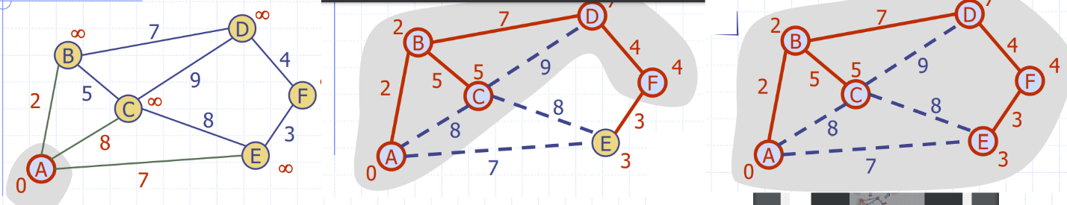

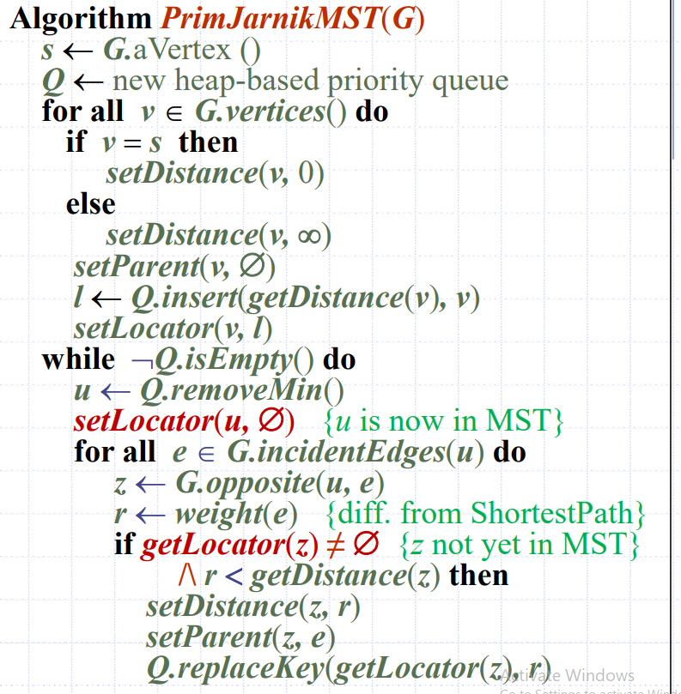

Kruskal (The MST edges are returned in a Sequence T)

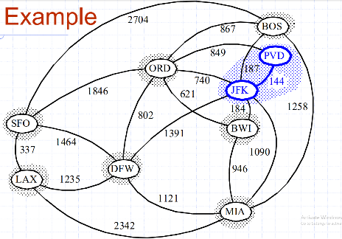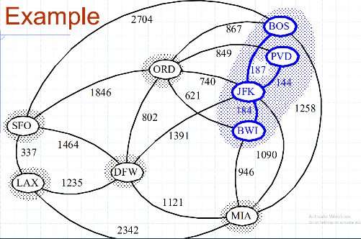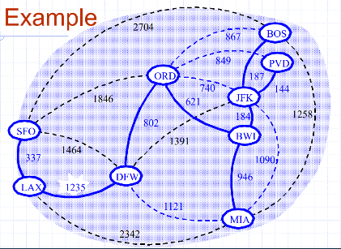

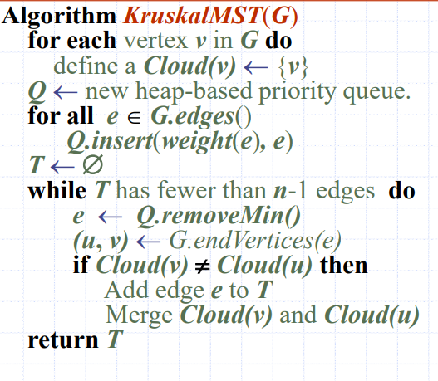

Each cloud/partition is stored in a sequence

Each vertex has a reference back to the cloud containing it, which is an integer index into the Clouds array

Kruskal’s minimum spanning tree algorithm first finds the shortest edge, then tests it for feasibility; if it passes, it becomes part of the proposed solution

Baruvka (The MST edges are labelled IN_MST)

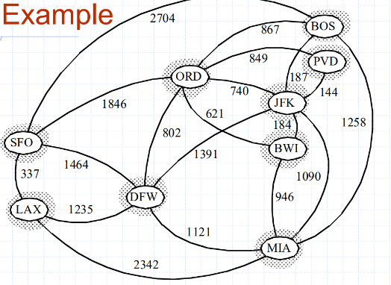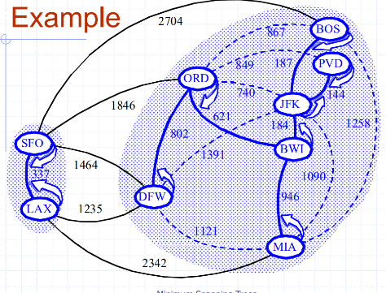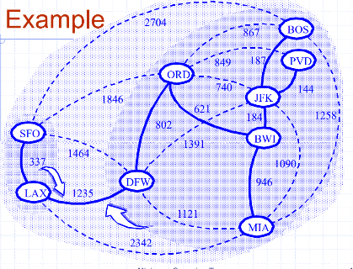

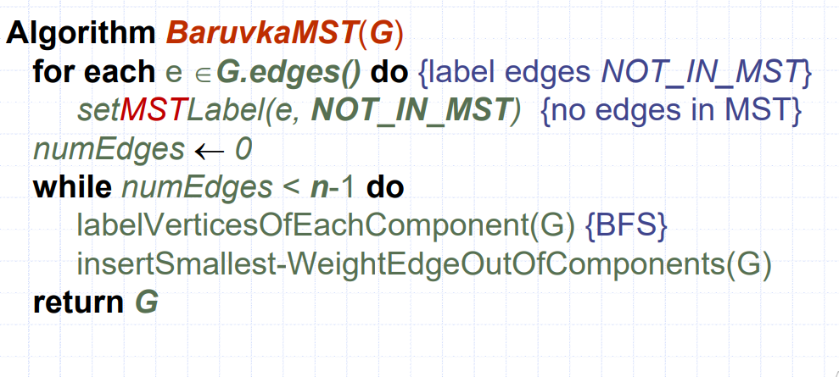

Maintains a forest T subject to edge insertion